## NSWMS SE- AUTOMATIC WEBSERVICE:

NSWMSSE –Automatic Web service required configuration.

1. NSWMS SE Automatic web service is automation whenever Ship manifest record created in custom record then record will update tracking number based on service level.
2. Service levels must be configured in Carrier Service level with proper information. These service levels provided in excel sheet.
3. Location must be provided in proper Address information. Need to provide “US” address information. Because present account details belongs to US

Company Name, Address1, Address 2, Zip, phone, city, and state.

1. Ship To information must be provided in Sales Order with proper address. Need to provide “US” address information.

Company Name, Addressee, Address1, Address 2, Zip, phone, city, state, and country.

1. FedEx and UPS account details (Developer resource center) need to be configured in below path. These account details will change based on customer. Customer need to provide below information at the time of Go-Live.

Present below details are test account details.

Based on requirement we need check the checkboxes in Web service setting screen.

Ex: FedEx Ship Manager and UPS Ship Manager check box checked

Settings🡪Web Service Settings

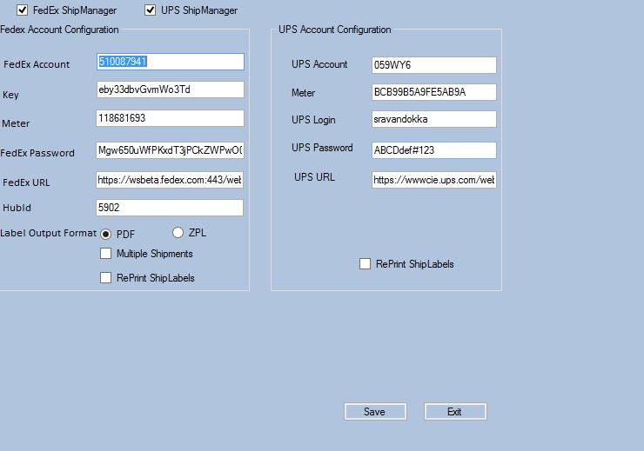

1. Customer need to configure the Laser and the zebra printers for ship labels printing and these printers should be configured as network printers.
2. For enable the auto shipping we need to configure the below changes in NSWMS Print driver

Settings🡪Configuration there need to check the Enable Automatic Integration checkbox as shown below.

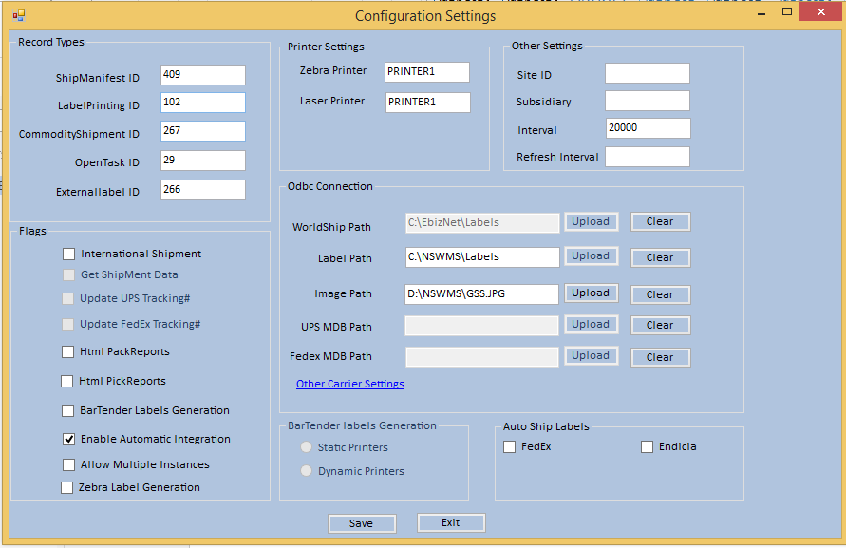

1. If any exception occurred in Track# number generation we are updating exception in Exception detail custom field of Ship manifest custom record
2. We are not process any exception message records through FedEx, ups. We need to resolve this issue and then remove the exception message. After removing the exception Integrator pull the information and generate the tracking number updated to NetSuite Custom record.